How to design quiz
To design QUIZ or any other application, you require a server tool. Node.js is the tools available to design client server functionality.
- Download Node.js
- Install Node.js in D:\ drive [recommended]
- When you install Node.js it as following other utility to be installed
- 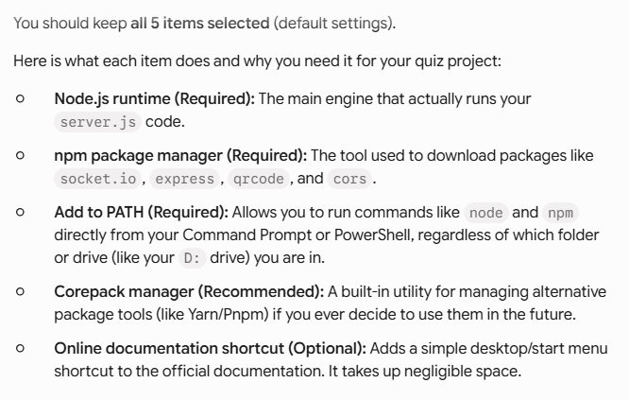
- Corepack manager is not required to install, also Online documentation also you can skip
- Once the setup finishes, open Command Prompt, switch to your D: drive, and test the installation by running:
- 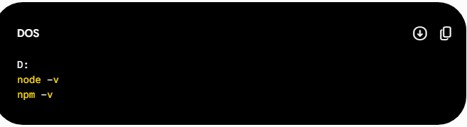
- If both commands show version numbers, your installation succeeded.

To design quiz or any application, we need to install the dependencies, which we will used in our program to collect data from client, send data to client etc.

- For each quiz you need to manage file structure like
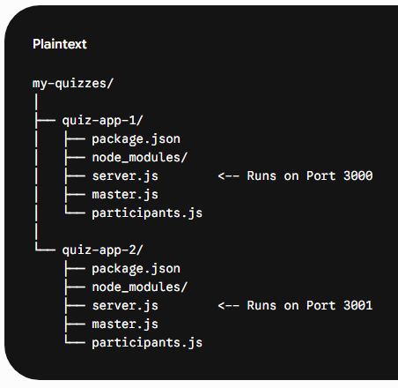
Workflow for a New Quiz Directory
- Navigate to the folder:
  - cd path/to/quiz-app-1
- Initialize a Node project:
  - npm init -y
  - 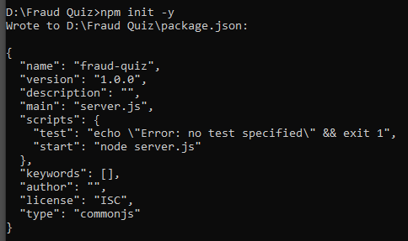
- Install the required libraries for that quiz:
  - npm install express socket.io
  - 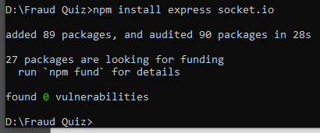
  - (This downloads packages into a node_modules/ folder inside only that project directory.)
  - Also install QRCODE also
    - Npm install qrcode
  - Now run the server to check that everything is file
    - Node server.js
- Apart from your server, participants, master files, now you will get additional files and directory which helps you to run the quiz as below:
- 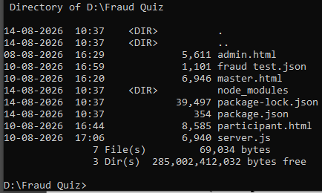

- Here are three runnable files to launch your complete real-time quiz setup locally.
- 1. server.js (Node.js Backend)
- Save this file in your project directory (D:\real-time-quiz\server.js):
- 2. master.html (Quiz Master Display Screen)
- Save this file as D:\real-time-quiz\master.html:
- 3. participant.html (Participant Mobile Screen)
- Save this file as D:\real-time-quiz\participant.html:
- ADDITIONAL SOFTWARE SETUP
- Check Your Command Prompt Location
- Make sure your terminal path matches the folder where your server.js file lives.
- In Command Prompt, run:
- Step 2: Install the Dependencies Inside the Folder
- Once you are inside D:\real-time-quiz, run this command:
- Step 2: Install the Dependencies Inside the Folder
- Once you are inside D:\real-time-quiz, run this command:
- 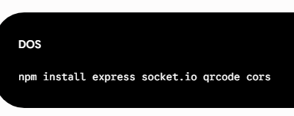
- This will download Express and create a folder named node_modules inside D:\real-time-quiz.
- Step 3: Start the Server Again
- Now run the server again:
- 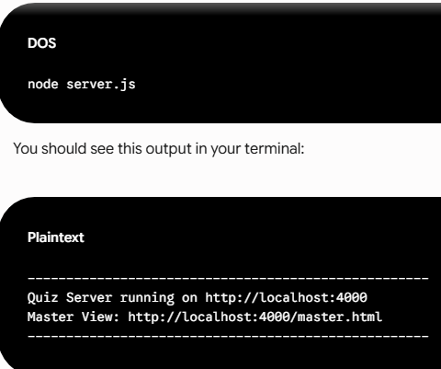

LIVE DEMO
Show me how to test the Master and Participant views step-by-step now that the server is running.
- Now that your Node.js server is running without errors, here is how to test the full interactive flow on your computer.
- Step 1: Open the Master View
- Open your web browser (Chrome, Edge, Firefox, or Safari).
- Type this URL in the address bar and press Enter:
- http://localhost:4000/master.html
- What you should see:

- 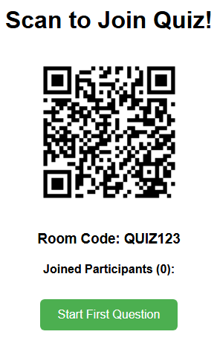
- Step 2: Open Participant Mobile Views (Simulate Multiple Players)
- To simulate actual participants joining on their phones:
- • Open a New Incognito / Private Window (or a separate browser tab).
- • Type this URL in the address bar:
- http://localhost:4000/participant.html?room=QUIZ123

MOBILE CONNECTIVITY PROBLEM
- Localhost cannot be recognised by the mobile
- This happens because localhost only works on the computer running the server. Your mobile phone doesn't know what localhost means on its own network—it needs your computer's local IP address (e.g., 192.168.1.15).

- Step 1: Install localtunnel
- Open your terminal in your project directory and install localtunnel as a development dependency:

- npm install localtunnel --save-dev

QUIZ TO BE PLATFORM INDEPENDENT- ANY NETWORK
Step 1: Push Your Code to GitHub
- Open your terminal in your project folder (or open GitHub Desktop).
- If using the command line, run:
git add .
git commit -m "Prepare for deployment"
git push origin main

- If you have got an error that “identity is unknown” then
- git config --global user.email you@example.com “soni4pankaj@gmail.com”
- git config --global user.name "Your Name" “soni4pankaj” GIT USERNAME

- RETRY
- git commit -m "Prepare for deployment"
- git push origin main
- In above step it will ASK you GIT Authentication
- What this means for your quiz app specifically:
- Your server.js file reads and writes questions using quiz-questions.json. Because free servers lack persistent storage, any new questions added via your Admin API while the server is live won't save permanently across server restarts.
- To ensure everything runs smoothly:
- Add your questions locally to quiz-questions.json in your code folder.
- Commit and push those changes to GitHub (git add ., git commit -m "add questions", git push). Render will automatically update your live server.
- Give it 30 seconds to wake up if you open the link after a break before participants join.

